Note:
1. April 17, 2025 - Email showing rotation schedule assignment for Lake Keowee. I was told “not to bother to go” to visit the office.
2. April 29.2025 The first email from me to Daniel Burke, Guided Luxury shows my initial agreement for him to sponsor an office opening event for up to $2k sent 4.29.25.
3. May 15, 2025 – I am not reassigned to Contender Development. Christine Brodsky contacts Daniel Burke and sends an email stating that this event costs $8,875. I have launched several offices while at Blackstream and we have never spent over a few thousand dollars (maximum). According to Lissa Lipsey, agent in charge of the Keowee office, Blackstream didn’t pay over $2,500 for this event. This is fraud and shows unethical practices and conspiracy to remove me from my position as Director of Marketing to get money from Guided Luxury. Lissa reported her concerns about fraud to Michael Mumma and Ford Elliott.
1. Email showing me on rotation to Lake Keowee office. I am handling all planning for the office opening event.
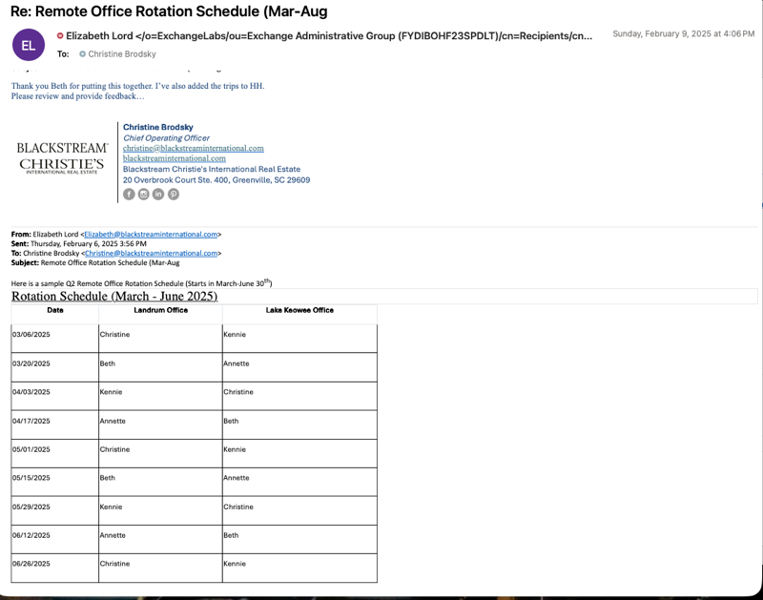

2. I am in contact with Daniel Burke at Guided Luxury magazine. He agrees to $2k to help sponsor the event.
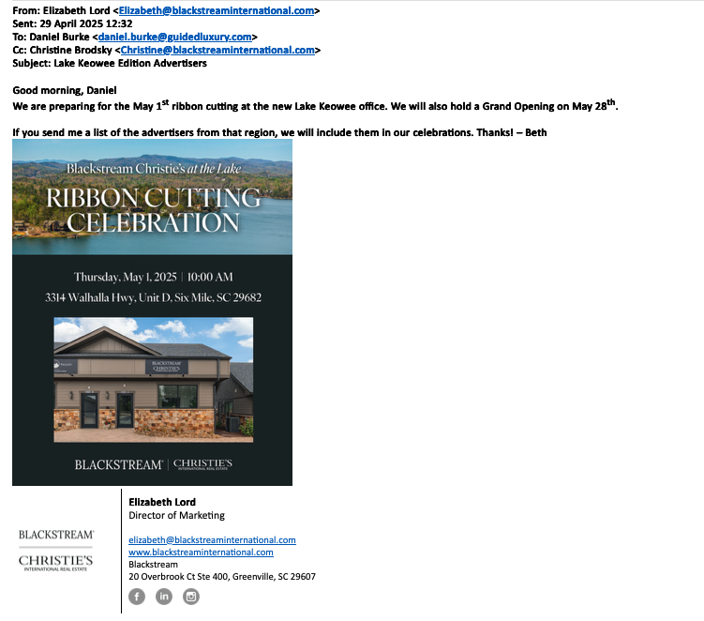
3. Email from Christine Brodsky to Daniel Burke indicating the event cost $8,875. She had already told Lissa Lipsey that Blackstream could only afford about $2,500 for this opening. The day prior, Lissa Lipsey contacted The Shephard (event venue) to confirm that funds were received from Blackstream. The Shephard indicated that only cocktails were included, no food, and that is all that Blackstream had ordered. This shows fraud and is representative of unethical practices throughout Blackstream International and Contender Development.
